**Experiment 5**

**Aim :** To write following shell programs

1. Write a script to check whether the given string is a palindrome.

#!/bin/bash

echo "Enter a String"

read input

reverse=""

len=${#input}

**for** (( i=$len-1; i>=0; i-- ))

**do**

reverse="$reverse${input:$i:1}"

**done**

**if** [ $input == $reverse ]

**then**

echo "$input is palindrome"

**else**

echo "$input is not palindrome"

**fi**

**Output :**

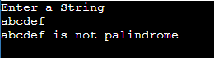

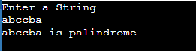

1. **Write a script to calculate the average of n numbers**

**echo "Enter Size(N)"**

**read N**

**i=1**

**sum=0**

**echo "Enter Numbers"**

**while [ $i -le $N ]**

**do**

**read num #get number**

**sum=$((sum + num)) #sum+=num**

**i=$((i + 1))**

**done**

**avg=$(echo $sum / $N | bc -l)**

**echo $avg**

**Output :**

1. **Write a shell script to find the sum of digits of a given number**

**#!bin/bash**

**echo "Enter a number"**

**read num**

**sum=0**

**while [ $num -gt 0 ]**

**do**

**mod=$((num % 10)) #It will split each digits**

**sum=$((sum + mod)) #Add each digit to sum**

**num=$((num / 10)) #divide num by 10.**

**done**

**echo $sum**

**Output :**

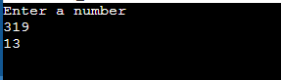

1. **Write a shell script to calculate factorial of a number**

**#!bin/bash**

**echo "Enter a number"**

**read num**

**fact=1**

**while [ $num -gt 1 ]**

**do**

**fact=$((fact * num)) #fact = fact * num**

**num=$((num - 1)) #num = num - 1**

**done**

**echo $fact**

**Output :**

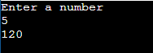

1. **Write a shell script to print fibonacci series up to given number**

**#!bin/bash**

**echo "Enter the value of n"**

**read n**

**a=0**

**b=1**

**count=2**

**echo "Fibonacci series:"**

**echo $a**

**echo $b**

**while [ $count -le $n ]**

**do**

**fib=`expr $a + $b`**

**a=$b**

**b=$fib**

**echo $fib**

**count=`expr $count + 1`**

**done**

**Output :**

